Phenotype Rescue Treatment with Combinatorial Screening via CellInsight CX7

Brittany G.

1. Experimental unit

* CellInsight CX7

2. Controls

* Untreated/Saponin cell lines

3. Replicates

* 6 replicas of anti-cancer dosage combinations

4. Batch size

* 96 well plate with an 8 x 8 combinatorial matrix corresponding to anti-cancer plus 2 columns on each side with saponin or no treatment

5. Reagents needed

* Propidium Iodide and Hoechst
* For assay detection of live/dead cells
* Cell culture: HeLa cells
* Anti-venom screening targets

(1) Cisplatin

(2) Metformin

(3) paclitaxel

(4) **Metformin**

(5) **Obatocoax**

(6) Tamoxifen

(7) Doxourbicin

(8) 5-Fu

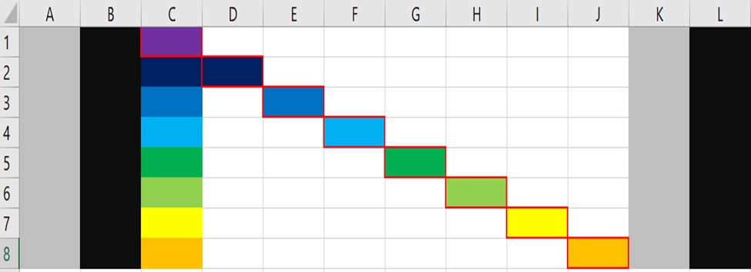6. Plate layout

* 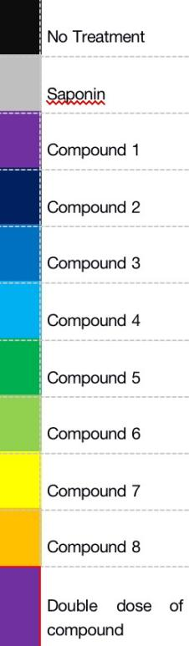Concentrations:

(1) Compounds 1-8 various concentrations

(2) Saponin 0.1 mg/ml

***Reference:***

1. Jungeun Kim, Hoe Suk Kim, Ga Yeon Kim, Kyung hyeun Park, Seung yeon Ryu, Sangeun Lee, Dong Woo Lee, Bosung Ku, Han-Byoel Lee, Wonshik Han; Abstract P5-02-02: Development of automated 3D high-throughput drug screening platform for patient-derived breast cancer organoids. *Cancer Res* 15 February 2022; 82 (4_Supplement): P5–02–02.
2. Mukundan, S., Bell, J., Teryek, M. *et al.* Automated Assessment of Cancer Drug Efficacy On Breast Tumor Spheroids in Aggrewell™400 Plates Using Image Cytometry. *J Fluoresc* **32,** 521–531 (2022).
3. Wallen CA, Higashikubo R, Roti Roti JL. Comparison of the cell kill measured by the Hoechst-propidium iodide flow cytometric assay and the colony formation assay. Cell and Tissue Kinetics. 1983 Jul;16(4):357-365. PMID: 6190563.

# Dosage HT Combinatorial Screening via PMA-qPCR

Matthew M.

1. Experimental unit

* QuantStudio 7

2. Controls

* Untreated cell lines

3. Replicates

* 4 replicas of controls
* 3-5 replicas of dosage combinations

4. Batch size

* Utilize the available size of the assay limited by the instruments or plates (typically 96 wells - 8 control wells = 90 /batch )

5. Reagents needed

* PMA or PMAxx

For assay differentiability between detection of live/dead cell

* Cell culture reagents for BLAST/control cells: Eagle Medium
* Screening targets

(1) Doxorubicin: 1

(2) Ibrutinib: 2

(3) Etoposide: 3

(4) Navitoclax: 4

(5) Dexamethasone: 5

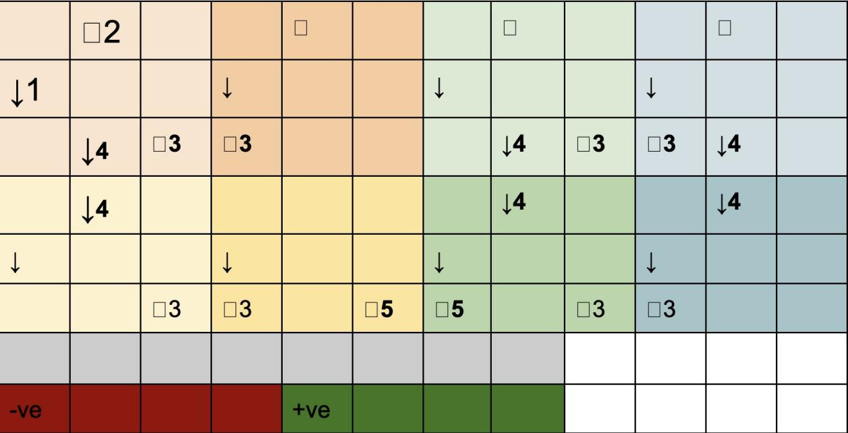6. Plate layout

7. Annotations

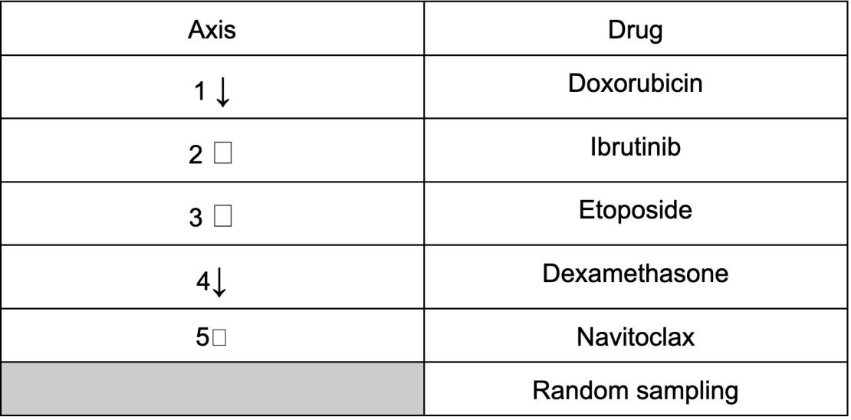

*Concentrations are yet to be finalized as their effective concentrations differ, however, a preliminary range (overestimated) is to be 0-2000 nM.

***Reference:***

1. Viability PCR - Biotium
2. [Cangelosi GA, Meschke JS. Dead or alive: molecular assessment of microbial viability. Appl Environ Microbiol. 2014;80(19):5884-5891. doi:10.1128/AEM.01763-14](https://www.ncbi.nlm.nih.gov/pmc/articles/PMC4178667/)
3. High-throughput combinatorial screening identifies drugs that cooperate with ibrutinib to kill activated B-cell–like diffuse large B-cell lymphoma cells

**Project Proposal**

Eric Li

1. VarioSkan Lux
2. Objective: Establish 5-Fu & cisplatin dose-dependent drug response prediction model
3. Plate layout: According to *Espino et al.*1 and *Długosz‑Pokorska et al*.2, the HL-60 cell line 5-Fu and cisplatin dose-dependent response curve are as following (24h incubation):

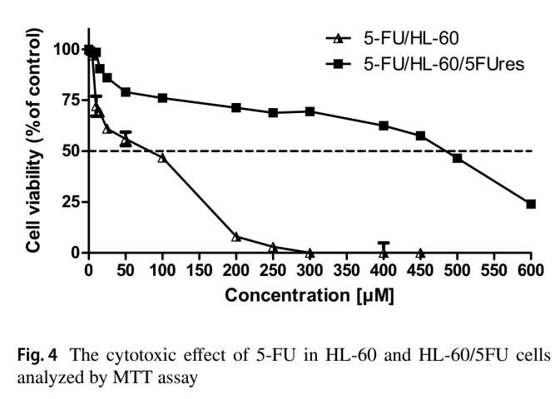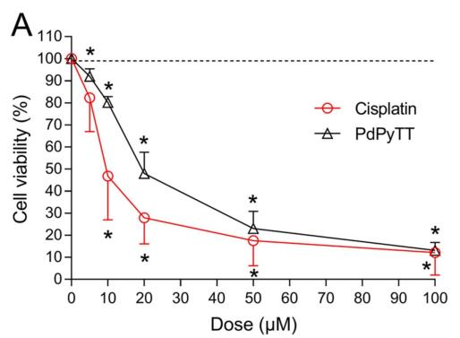

Since we want to test the combination effect of 5-Fu and cisplatin, we will test the following concentration range:

We will use MTT assay to measure cell viability according to absorbance reads.

A

B

C

D

E

F

G

H

1 2 3 4 5 6 7 8 9 10 11 12

Positive control 1 (400 μM 5-Fu)

Negative control (DMSO)

0

30

60

90

120

150

Positive control 2 (200 μM cisplatin)

5-Fu (μM)

0

15

30

45

60

75

Cisplatin (μM)

1. Replicates: We will have 3 replicates, which means that 3 plates above are to be processed at Cybio Felix at the same time. The final viability, which will be fed into the active learning model, is the average of 3 wells at the same position in 3 plates.
2. Experimental unit:

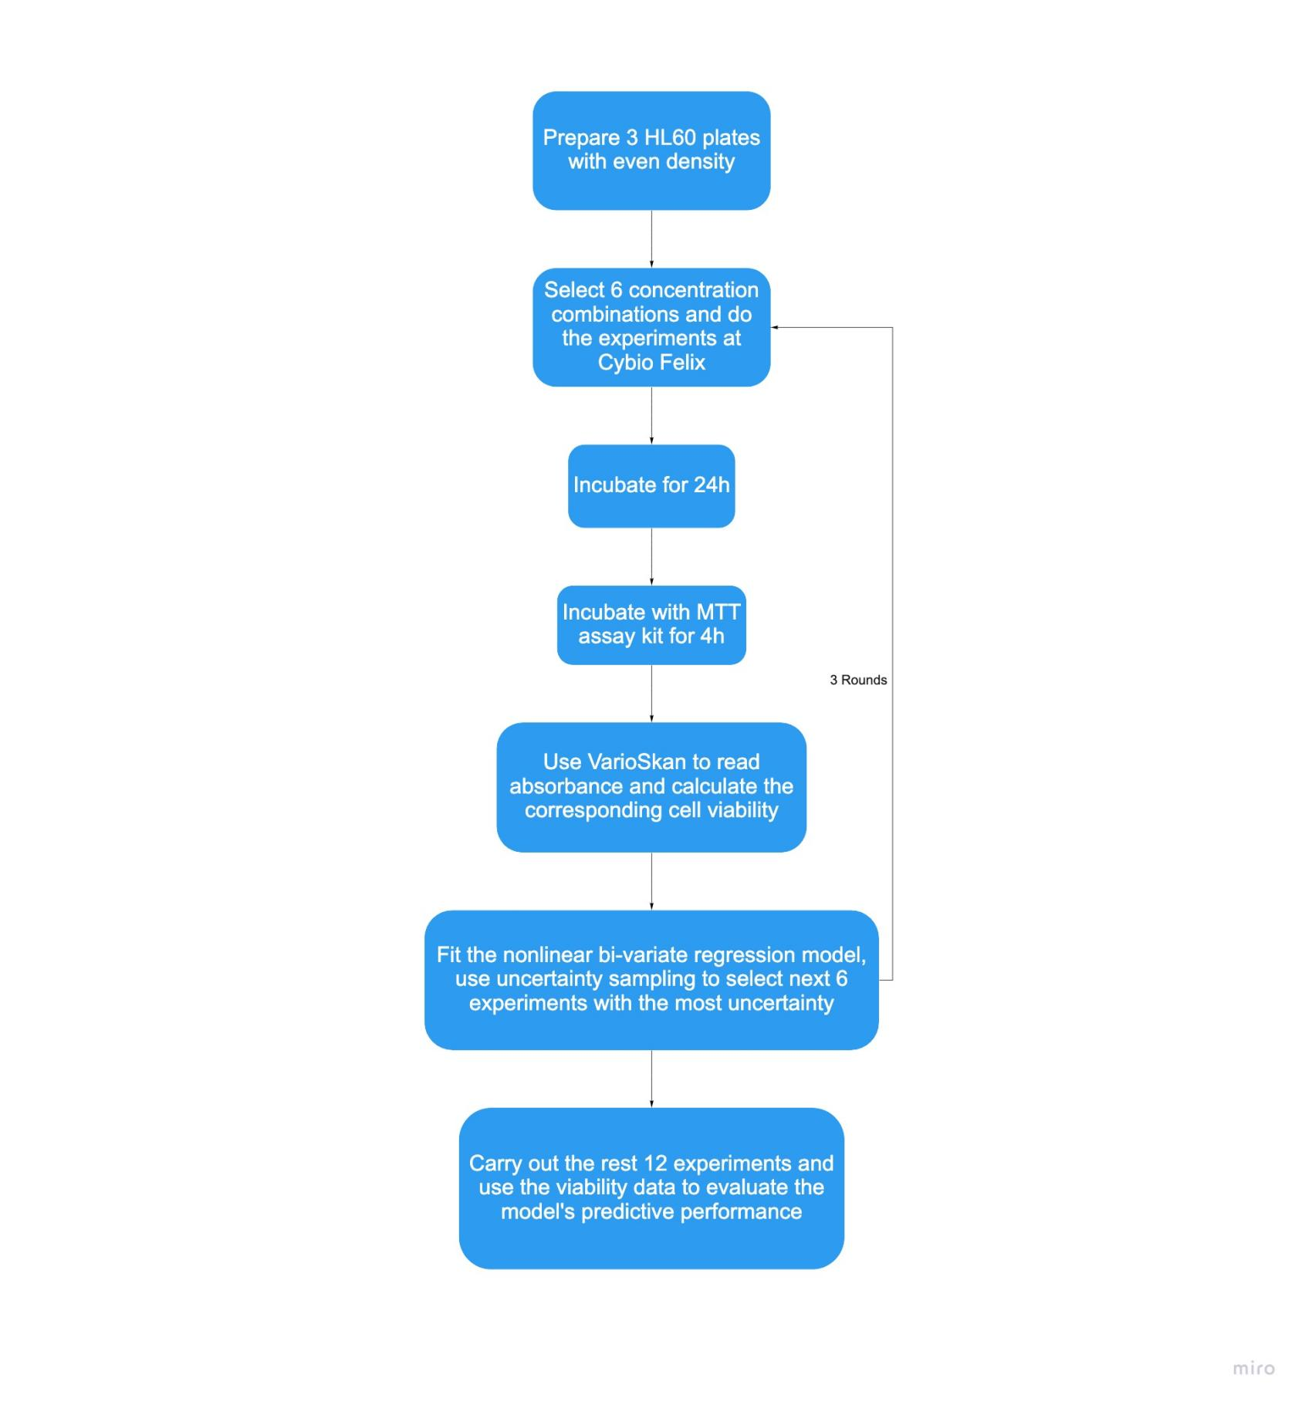

1. Reagents needed: 5-Fu, cisplatin, DMSO, cell culture medium
2. Time estimation: cell culture: 2 days; experiment: 4 days.
3. Datasets:

Several dose-dependent drug-response matrices3 can be used to test our active learning algorithm:

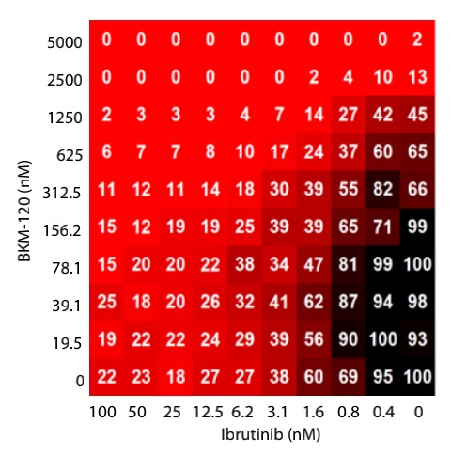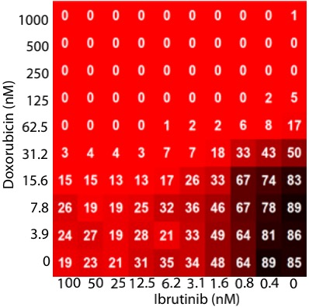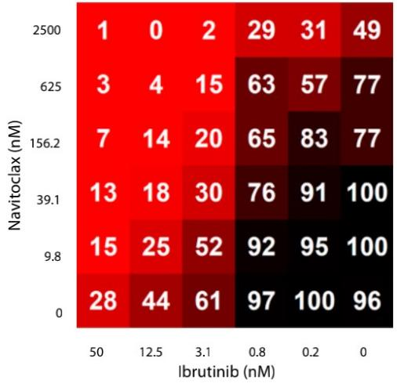

***Reference:***

1. Espino, J., Fernández-Delgado, E., Estirado, S. et al. Synthesis and structure of a new thiazoline-based palladium(II) complex that promotes cytotoxicity and apoptosis of human promyelocytic leukemia HL-60 cells. Sci Rep 10, 16745 (2020). https://doi.org/10.1038/s41598-020-73488-0
2. Długosz-Pokorska, A., Pięta, M., Janecki, T. et al. New uracil analogs as downregulators of ABC transporters in 5-fluorouracil-resistant human leukemia HL-60 cell line. Mol Biol Rep 46, 5831–5839 (2019). https://doi.org/10.1007/s11033-019-05017-w
3. Mathews Griner LA, Guha R, Shinn P, Young RM, Keller JM, Liu D, Goldlust IS, Yasgar A, McKnight C, Boxer MB, Duveau DY, Jiang JK, Michael S, Mierzwa T, Huang W, Walsh MJ, Mott BT, Patel P, Leister W, Maloney DJ, Leclair CA, Rai G, Jadhav A, Peyser BD, Austin CP, Martin SE, Simeonov A, Ferrer M, Staudt LM, Thomas CJ. High-throughput combinatorial screening identifies drugs that cooperate with ibrutinib to kill activated B-cell-like diffuse large B-cell lymphoma cells. Proc Natl Acad Sci U S A. 2014 Feb 11;111(6):2349-54. doi: 10.1073/pnas.1311846111. Epub 2014 Jan 27. PMID: 24469833; PMCID: PMC3926026.